GEOL 551: Applied Petroleum Geology   
Assignment #7 - Due 4/1/2019

Nadima Dwihusna

**Homework Task**

* Niobrara Interval do Fill Picking and 3d Hunt Picking

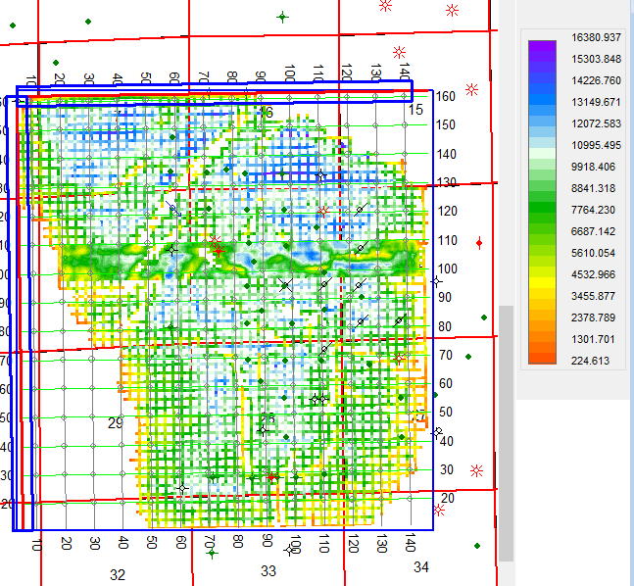

Figure 1: Niobrara every 3 interval pickings (using Fill “F” picking type)

for all inlines and cross lines

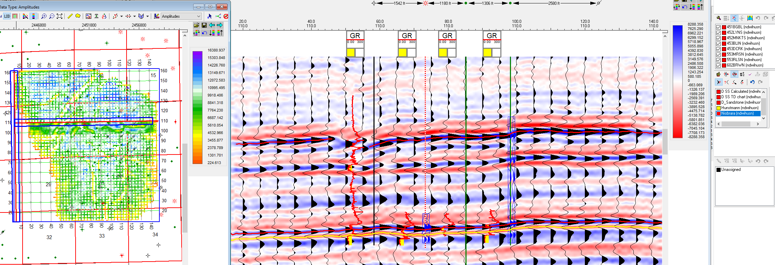

Figure 2: Niobrara Horizon Pickings Example at Crossline 110.0

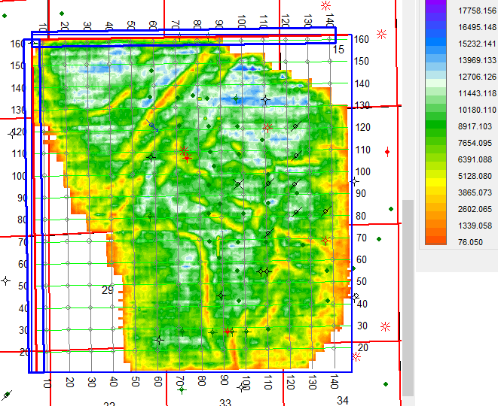

Figure 3: Amplitude Map of Niobrara 3D Hunt Structure showing the

prominent faultings and structure around the area

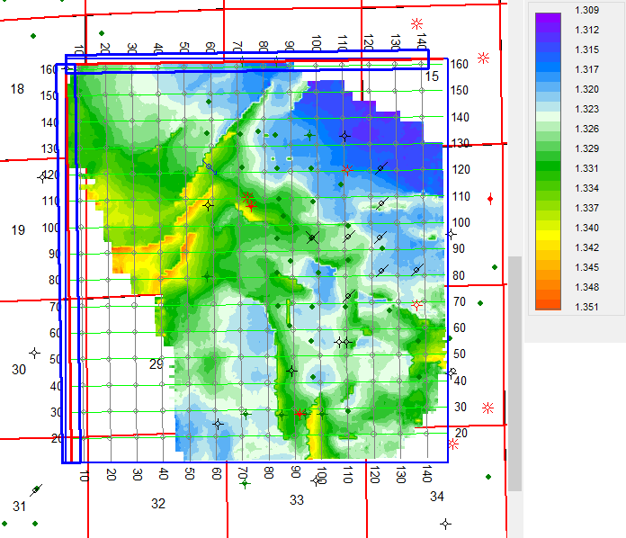

Figure 4: Time Map of Niobrara 3D Hunt Structure also showing the

prominent faultings and structure around the area